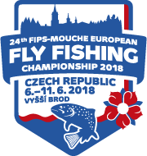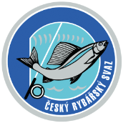

**24th FIPS Mouche European Fly Fishing Championship**

**Vyšší Brod, Czech Republic, June 6th - June 11th 2018**

**REGISTRATION FORM**

|  |  |
| --- | --- |
| **TEAM** |  |
| **Official address of federation:** |  |
| **Contact person/manager:** |  |
| **e-mail:** |  |
| **mobile phone:** |  |
|  |  |
| **Competitor 1** |  |
| **Competitor 2** |  |
| **Competitor 3** |  |
| **Competitor 4** |  |
| **Competitor 5** |  |
| **Reserve** |  |
| **Captain** |  |
| **Manager** |  |
| **Date of arrival** |  |
| **We would like to book the same accommodation before championship** | **YES/NO** |

**Number of single rooms:……………Number of double rooms:..……….**

**Number of triple rooms:………….. Cottage:…..…………….**

**Date: …………………………………. Signature:…………………………………..**